Look at these shocking statistics:
The percentage of men who admit to committing infidelity in any relationship they have had is 57%.

The percentage of marriages that end in divorce in the United States is 53%.

The percentage of marriages that last after an affair has been admitted to or discovered is 31%.

The Islamic Attitude to Polygamy

These statistics are not surprising. In its continuous pursuit of pleasure, humanity has not succeeded in regulating relations between men and women outside divine religions.

Islam, the final divine religion, has superseded earlier religions.

Anyone who thinks that Muslims give paramount importance to pleasure because Islam allows a man to marry up to four wives at the same time should have a careful look at the following figures. They confirm that the overwhelming majority of men in the United States have more than one partners. The number of partners may go up to 21.

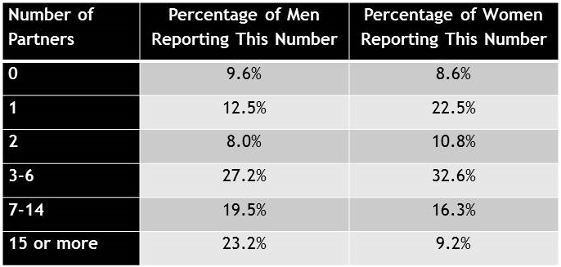

And we need to look at this table

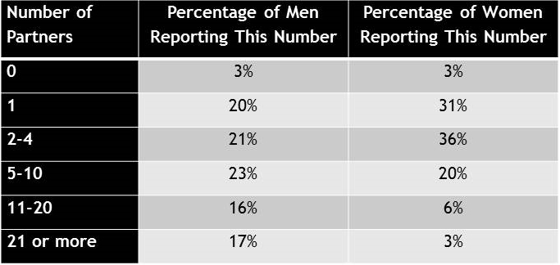

Moreover, 2-3% of children are brought up by men who are not their real fathers because they are the result of adulterous relationships.

Islam protects society against such abuse, but does not give man any absolute authority. It lays down certain controls, the first of which is to set a maximum of four wives. Secondly, for a man to marry more than one wife, he should be able to support them and fulfil his marital duties. Thirdly, he must treat them with absolute fairness. God says in the Qur’an: ‘If you fear that you will not be able to maintain fairness between them, then marry only one’. (4: 3) Fairness includes dividing nights equally between one’s wives and giving them the same standard of living, as well as all other areas of marital life.

Moreover, according to a large number of Islamic scholars, a woman may stipulate in her marriage contract that her husband may not marry another woman. Even if she does not do so, and her husband marries another woman and treats her unfairly, depriving her of some of her rights, she may apply for the termination of her marriage. This means that Islam permits polygamy provided that it does not lead to unfairness to anyone. By what right can anyone say: ‘We shall deprive these people of what their free choice?’

Some people claim that polygamy constitutes an insult to women. Here we ask a question that may be answered by anyone whose vision is not blurred by pornographic films or casual relationships: Which is a greater insult to a woman: to be party to an adulterous secretive relationship or to be a respected wife of a man who looks after her?

I do not think we need to wait for an answer.
https://www.youtube.com/watch?v=aHYO6fR_WaI

